2021

About Rick Rainbolt…

Rick founded Hemp Geo Institute, LLC. on January 10th, 2017. Over the past several-years, HGI has established itself as the ‘go-to’ organization for world-class education, resources and the development of CRAFT premium exotic flower grow operations.

As of July 31st, 2021, HGI has developed thirty (30) closed environment grow operations in multiple states, held nine (9) sold-out symposiums attracting attendees from 36-states and multiple ‘in-facility’ (Hands in Dirt) training events.

HGI’s certified facilities are hygienical environments for biologic methods and organic best practices and are designed for perpetual high-yield grow cycles, giving clients a year-round production schedule. HGI’s innovative process maintains the True Organic Value or “Composition” of the Hemp/Cannabis plants’ medicinal potential without the added physical deterioration which distorts the final product.

The result is full-spectrum, whole-plant concentrates that smell, taste, and test at the highest level of medicinal effectiveness. ​ Rick has played a role in the Legislative process in helping states become legal to grow Industrial Hemp/Cannabis in addition to consulting on the development of rules and regulation packages.

Helping other states become legal to grow Hemp/Cannabis, in addition to having helped dozens of individuals navigate the permit application process, is one of Rick’s ways of giving back to the industry.

+ Founder: Rick Rainbolt
+ Founded: January 2017
+ Charlotte, NC
+ URL: HempGeoInstitute.com
+ Industry: Hemp/Medical Cannabis

Highlights:

• Craft premium exotic flower grow operations
• Developed thirty (30) grow operations
• Nine (9) symposiums through US
• Awarded eighteen (18) Master Grow certifications
• Multiple strategic partnerships
• 1,000’s of Passionate Cannabis Followers

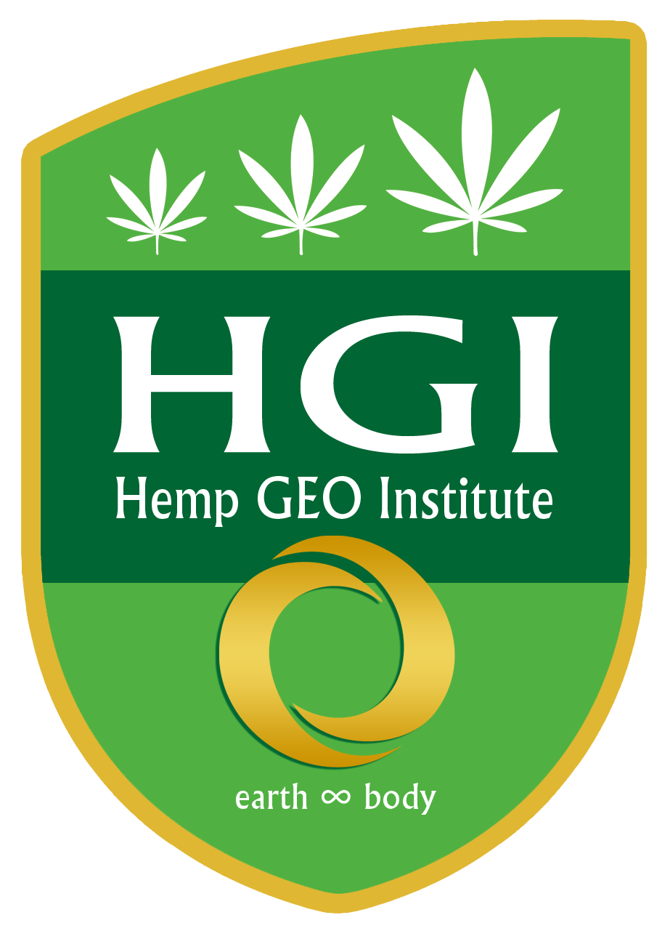
HempGeoInstitute.com

Premium exotic flower grow operations, education, and opportunity for the Hemp/Cannabis industry.

NOTE: Justin Esquivel, founder of Green Lusters Phenos has been an affiliate partner of Hemp Geo Institute, LLC. for the past 4-years. Within the “How to Develop and Succeed in the Premium Exotic Flower Niche” presentation, Justin speaks on genetics and cultivation.

About Justin Esquivel…

Justin Esquivel, president/founder Green Luster Phenos, LLC and Chief Genetics & Headmaster Grower for Hemp Geo Institute, LLC has been an influencer and leader in the cannabis industry for twelve (12) years. Justin was the headmaster grower and lead a genetics division of a large 20,000 sq. ft indoor commercial-scale cultivation operation based out of Colorado.

Justin also had his hands in the development of two more commercial size operations in 2012 in the medical cannabis sector. He brings standard operating procedures to a gold standard. Justin collaborates with many other expert breeding companies based out of Spain & Amsterdam allowing his genetics company the ability to bring an entirely new genome to the states!

A genome that is one of a kind and scarce on the market. Justin specializes and with great passion, in creating superlative genetics that provide growers predictable and uniform offspring. He provides Green Luster Phenos to a highly selective group of licensed growers.

His unique methodology of selective homozygous breeding and cannabis specific stratification has attracted the top thought leaders in the breeding world.

When he’s not in one of his breeding chambers or out in the field consulting, he’s at home with his lovely wife and beautiful daughter.

+ Founded: January 2015
+ North Carolina, USA & Spain, Madrid
+ URL: GreeenLustersPhenos.com
+ Industry: Traditional Agricultural - Premium
Hemp/Commercial Cannabis

Highlights:

• Created 24 strains since founded
• Sealed HEPA & UV-C filtered facility
• Master grower of 12 Operations
• Lead Geneticist in 2012 of commercial scale cannabis operation
• Implemented unique breeding programs with homozygosity in mind
• Collaborations with Spain & Amsterdam breeders

